**1. Introduction**

* **Overview**: Introduce the **FreshEra Careers** job portal, explaining its goal to help freshers find job opportunities by providing information about companies, their minimum salary packages, eligibility, roles, and locations.

**2. Problem Domain**

* **Challenges**:
  + Freshers often face difficulties in finding jobs that match their skills, location preferences, and salary expectations.
  + Difficulty in comparing multiple companies offering different job roles with varied eligibility criteria.

**3. Solution Domain**

* **Proposed Solution**: **FreshEra Careers** is a specialized job portal that aggregates and organizes company details, such as packages, roles, eligibility, and locations, to help freshers make informed decisions. It also includes features like sorting, filtering, and comparing companies based on salary, roles, and more.
* **Key Features**:
  + **Dashboard**: Displays company details with sorting and filtering options.
  + **Company Comparison**: Allows side-by-side comparison of companies.
  + **Placement Schedule Planner**: Helps users plan their preparation schedules.
  + **Search and Filter**: Enables searching for companies by name or filtering by eligibility criteria and packages.
  + **Top Companies List**: Highlights the top companies offering the best packages for freshers.
* **Prototype**:

**4. Expected Outcome**

* **Primary Objective**: Provide freshers with an easy-to-use platform that simplifies the job search process, offering better insights and comparisons of companies.
* **Expected Benefits**:
  + Enhanced decision-making process for freshers.
  + Easier and quicker job search and application process.
  + Improved visibility of job opportunities from top companies.
  + Optimized scheduling for placement preparations.

**5. Requirements**

* **Software Requirements**:
  + Programming Language: Python/React JS (for backend and frontend).
  + Web Framework: React.js for front-end development.
  + Additional Tools: Libraries for sorting (e.g., heapq for heaps).

**6. DSA Algorithms Used**

* **Hash Maps**: Used for storing and retrieving company data efficiently based on keys (e.g., company name).
* **Arrays**: Used for storing and manipulating data, like company lists.
* **Binary Search**: Implemented for fast searching within sorted datasets.
* **Sorting Algorithms**: Quick Sort, Merge Sort, or similar to order companies by salary, rating, etc.
* **Heap (Priority Queue)**: Used to maintain and retrieve the top N companies offering the highest packages.
* **Linear Search**: Used for filtering companies based on user-selected criteria.

**7. Software Used**

* **Development Environment**: Visual Studio Code.
* **Frontend Technologies**: React.js for building the user interface.
* **Backend Technologies**: Flask
* **Version Control**: Git (for source code management).

**8. Methodology Used**

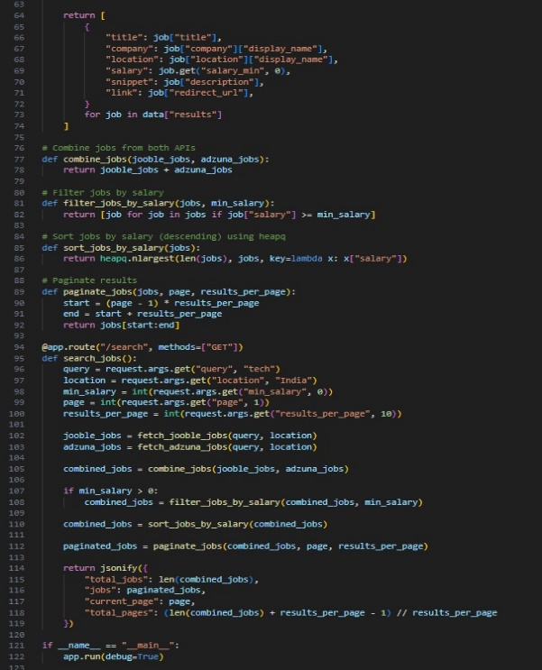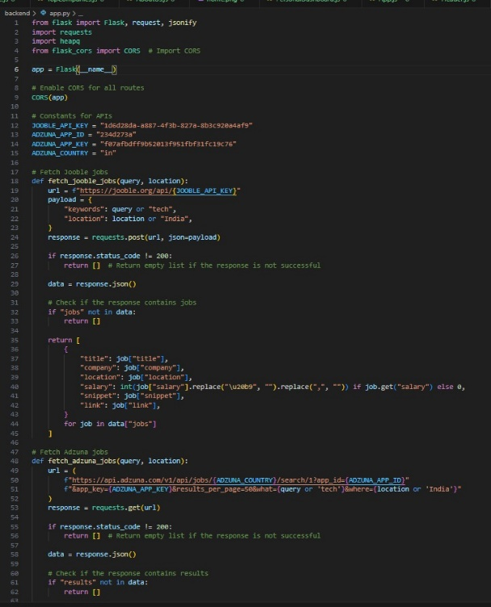

**Flow Diagram**

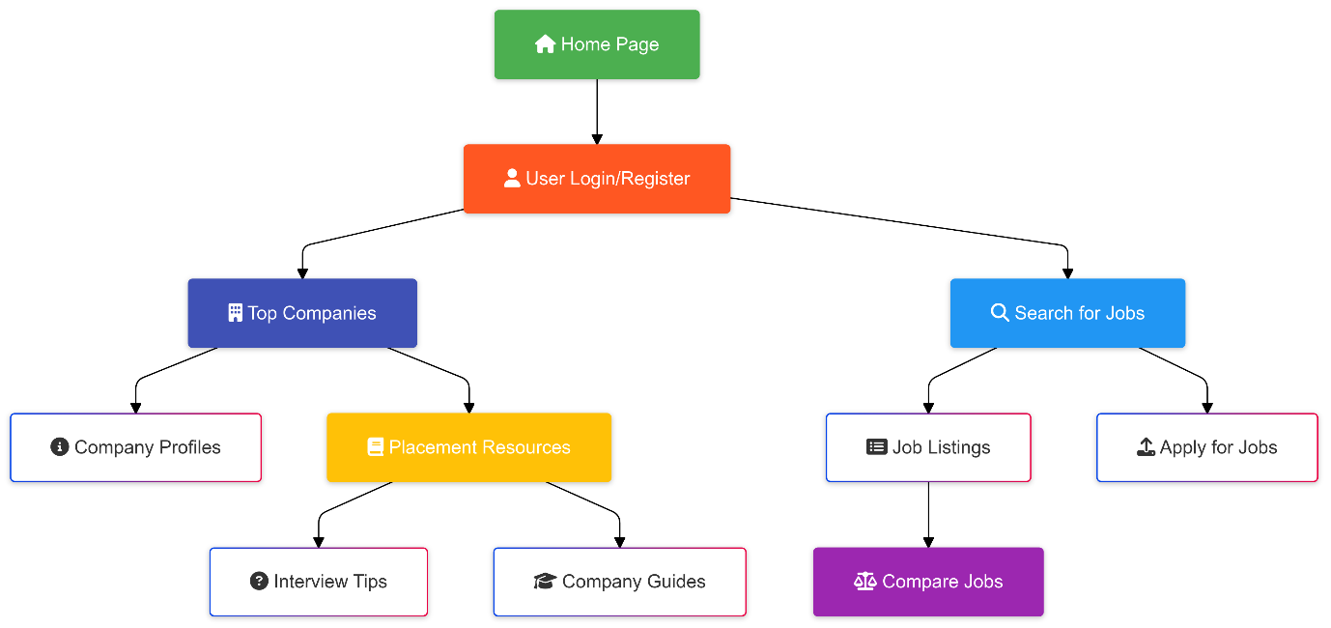

**9. Conclusion**

* **Summary**: The **FreshEra Careers** job portal aims to simplify the job search process for freshers by using advanced DSA concepts like sorting, searching, and filtering. It also offers key features such as company comparison and placement schedule planning. This platform ensures an enhanced experience for freshers and provides them with the tools needed to make informed decisions.
* **Impact**: The implementation of DSA algorithms ensures that the portal performs efficiently, even with large datasets. The system can scale and provide freshers with relevant job opportunities quickly. The project has the potential to make a real impact by improving the placement process for freshers.